Wireframes for Scholastic

**Phase 2:**

**SCHOLASTIC**

**Q7a** Create a main job story

The main reason that a user would go onto the website, is to look for and find a interesting books, and school supplies for their kids, help them find ideas to make their kids learn and keep kids reading instead of them playing video games. The site also has some educational features like courses from grade K- grade 3. Another reason that a user would go to this website is to purchase toys and games to keep their kids available and has pointers to keep kids occupied.

**Question 7B,C, and 9 are explained in the wireframes**

**Q8.**

1. Bad labeling on the home page
2. Not clear where to go on home page, multiple clicks instead of one
3. Kids section leads you to another page, which is not needed at all and is unfinished
4. The kids section has unnecessary headers and links, just taking up space and are not needed
5. Some links don’t work
6. In mobile display it is flawed, and takes out necessary features (navbar, links for books)
7. Ridicules way to order books
8. Really un appealing way to find books, only the first 6 books have images, others are links
9. Pointless links that are already there
10. **There is no way to buy books from the original scholastic page, unless you are a teacher or a Educational person/take the time to call scholastic and make an account**
11. Some navigation labels need to be better written
12. **There is also no way to buy books on the other site that scholastic said that you can purchase books, because the Icon is missing to add to cart**

**Q7b Wireframes**

**MUCH EASIER TO SEE IN VISIO, I would recommend viewing it there**

The first thing I did was rework the entire website, moving things so that they have more function and changing the names and making a better layout of the website, something that they managed to do completely backwards.

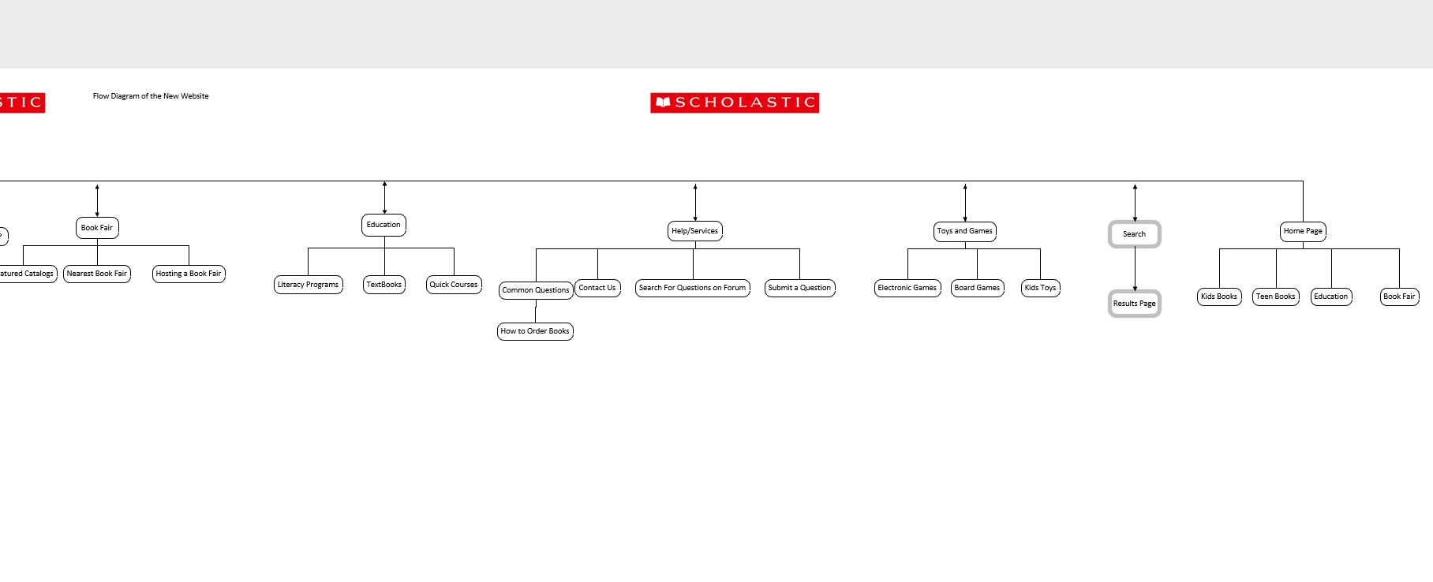

Showing Home page, Toys/Games, Help/Services, Education, Book Fair

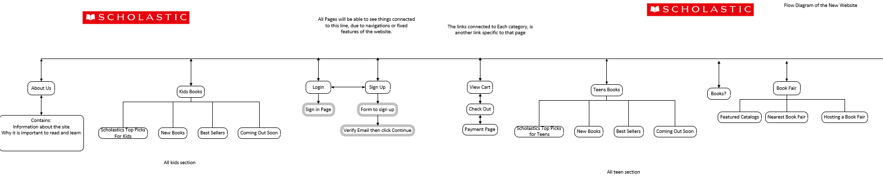

Then Showing the About us page, Kids Books, Login, Sign Up, View Cart, Teens Books, and shows connecting bookfair

**Home Page**

The things I changed from the original are

1. Fixed up the labels for the home page

Made sure that the user knew what he was clicking allowing the user to navigate the page more easily and made the flow of the website smoother

2. made the home page more functional

By adding Teens, Kids and education sections allowing the user to go to these sections quicker and without much thinking when they first come onto the website, I also added a feature that when you click the round button, it would drop down more items, and then be able to click if you want to continue to that category

3.Added the social media into a better position

I added social media from the bottom of the page to the top to make people who like viewing books and other items be more aware that we have the social media pages

4. Changed the names of the navigation bar to better suit the changes I made to the flow of the website

These changes were needed to be done because the navigation bar before was so badly made that I had to re flow everything so that it is made much smoother and makes it feel like an actual website that is meant to sell things.

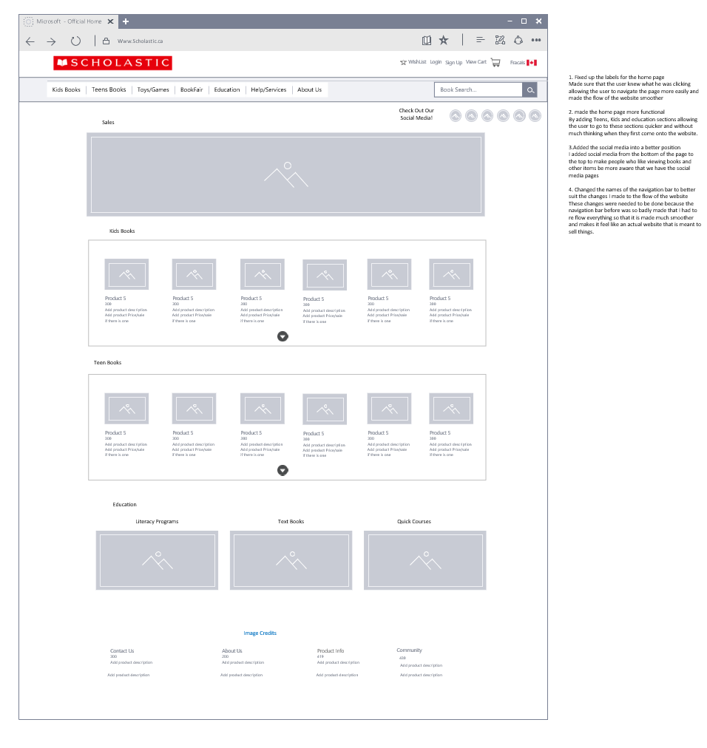

**Scholastics Home Page**

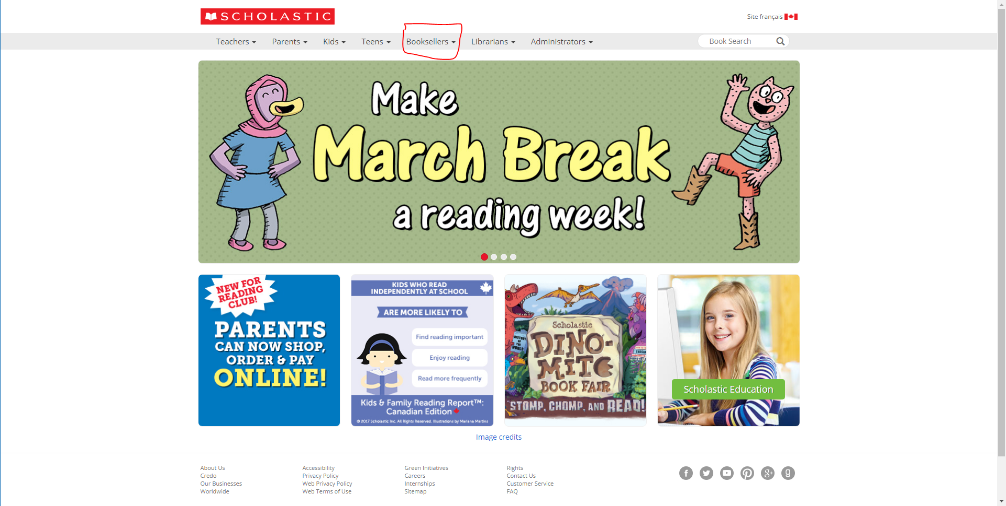

**Kids and Teens Pages**

The Next page I changed was the Kids and Teens Pages, to have similar design so it is easy for users to grasp the fundamentals of my website.

The things I changed in these webpage are

1.Completely Changed the home page for kids so it looks similar to the Home Page

2.I took away the unfinished items

Like the favourite Series & Authors

3.I made the interface look cleaner and more functional

Took away the clutter and changed it so the pictures are all the same size and format

4. removed the “New In March” and instead placed it in the nicely formatted boxes and once you click on the boxes you can see the categories and filters from there.

5.Made it so when you click a page it will take you to pages where you can search for your items, with pictures and better filters.

6.removed the blue extra nav bar that had some of the same links as the actual nav bar

7. added toys and games because it’s the kids section and it would have a positive effect on more things to buy

**My Wireframe design for Kids Home Page**

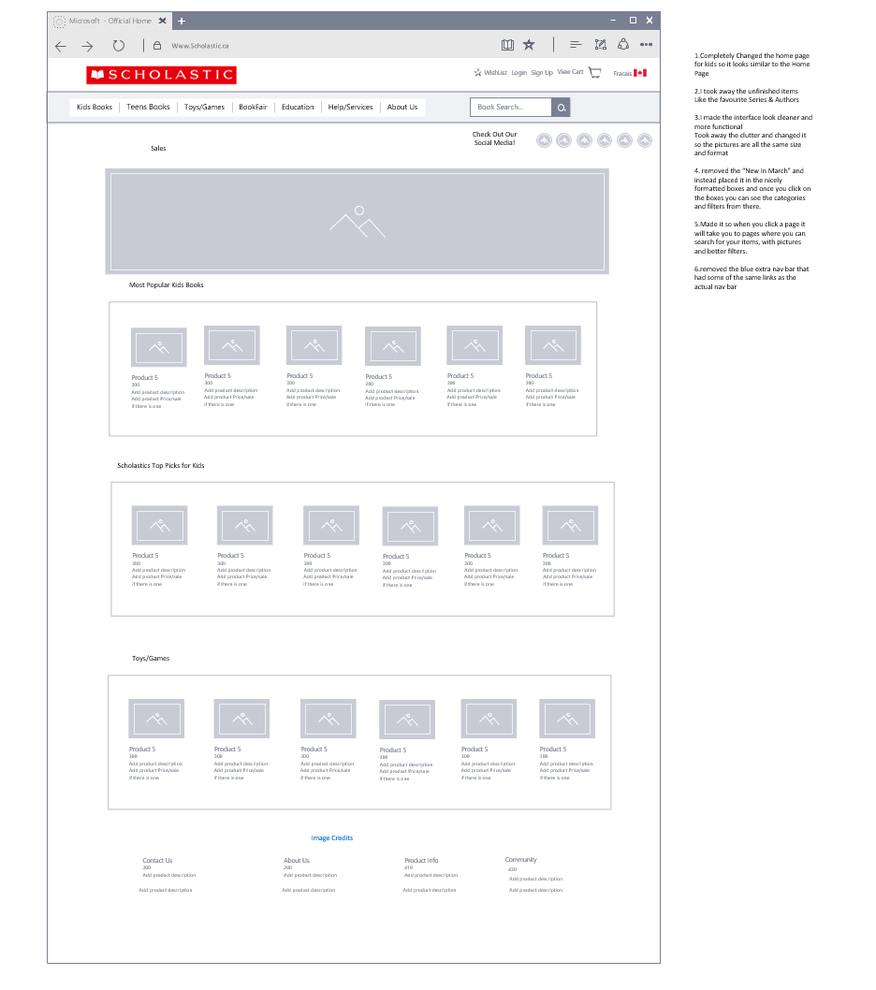

**Scholastics Kids Home Page**

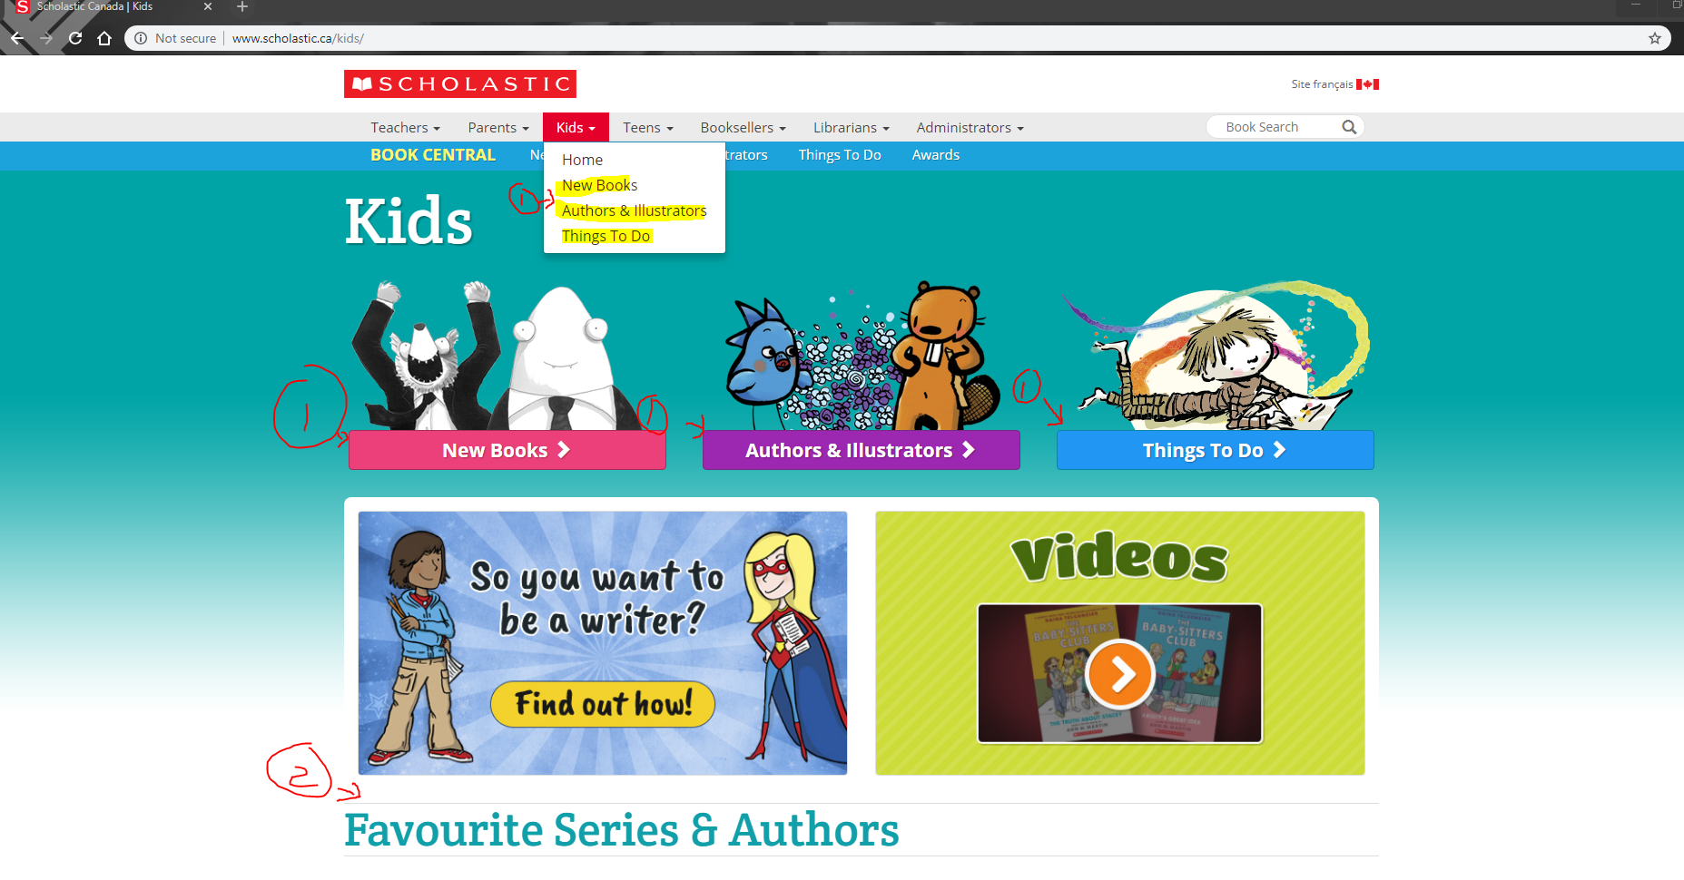

**TEEN Home Page Differences**

1. Changed the different sized images as it threw me off
2. Made it so that it follows the flow of the kids browsing pages, and made sure they both look useful and can be used simultaneously
3. Changed it so you can look for specific books, and encouraged teens to read text books
4. Made the interface nicer and much nicer

**Wireframe For Teens Page**

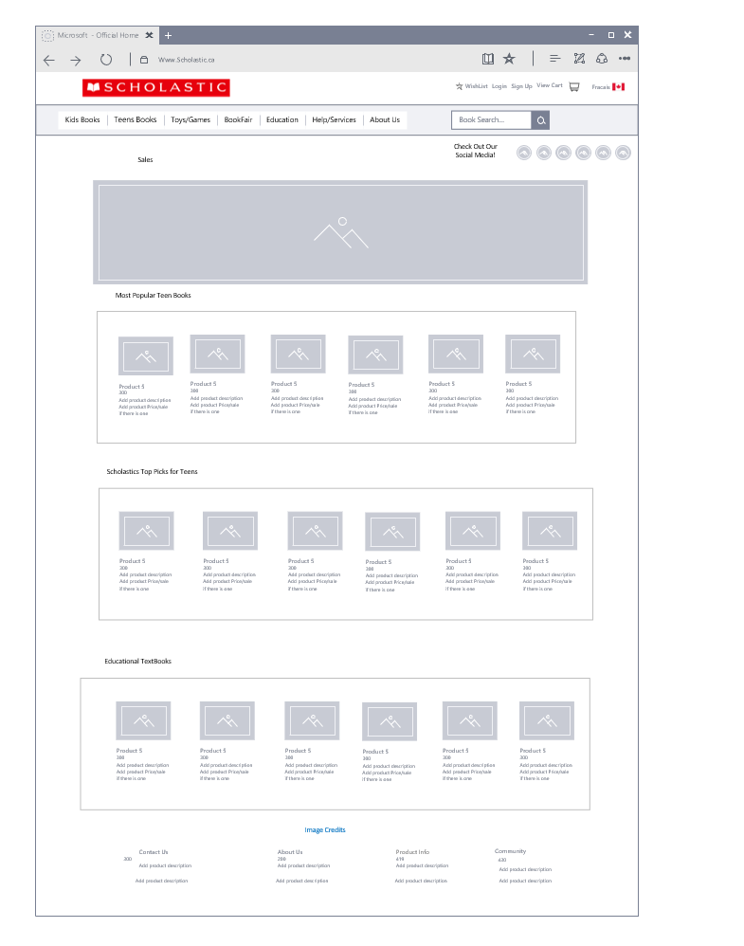

**Scholastics Teen Home Page design**

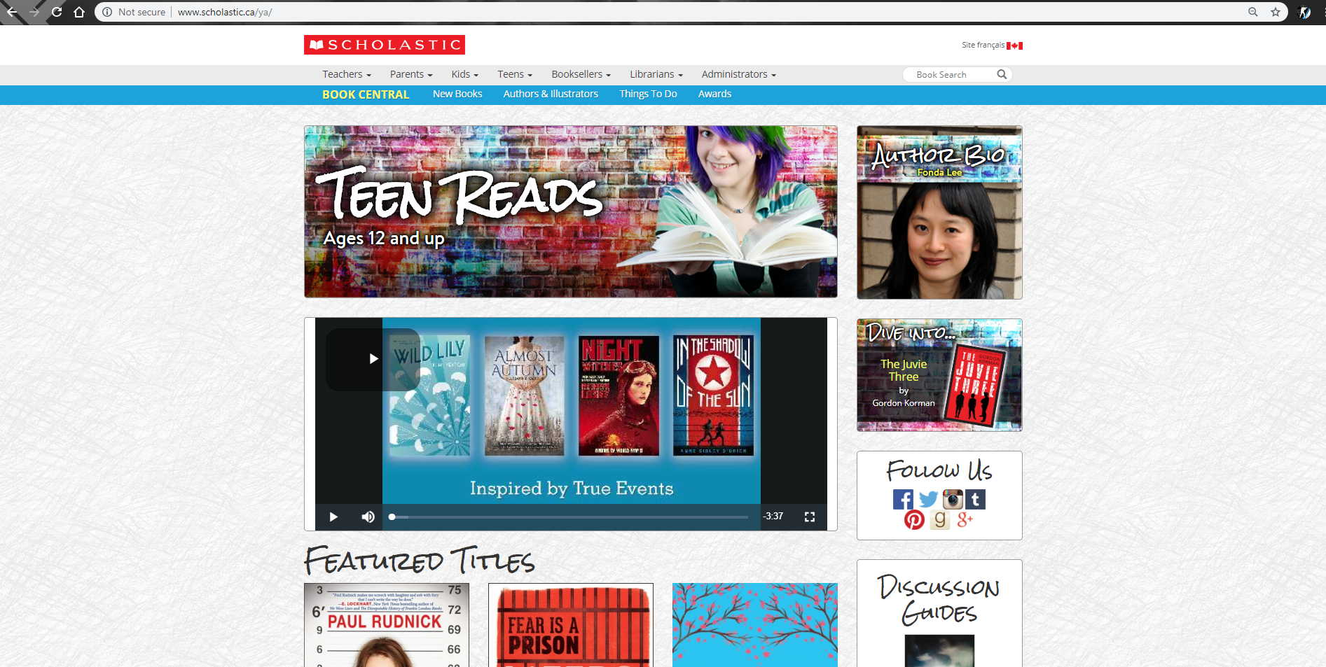

**Scholastics Kids page for viewing books, note that teens did not have one**

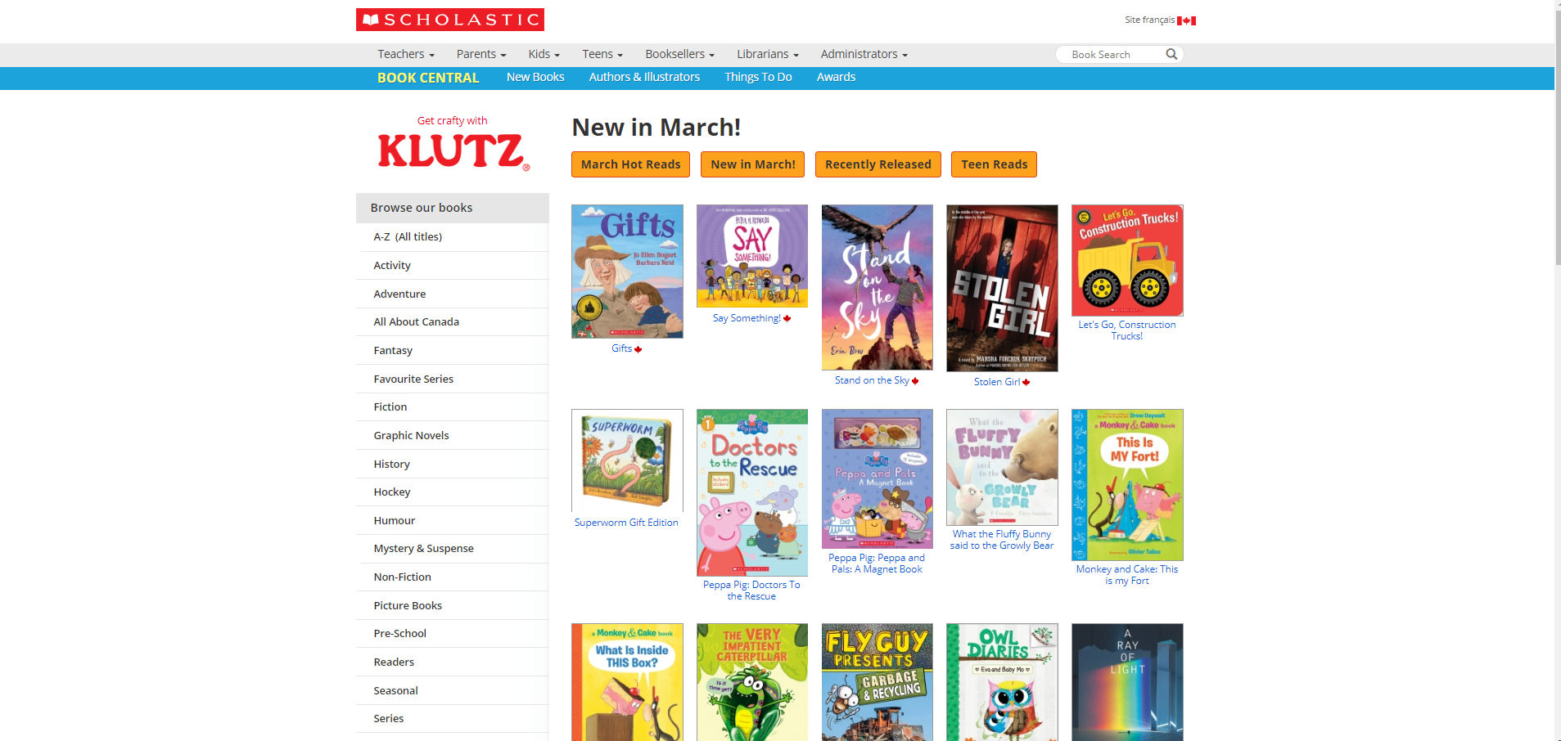

**Specific Book pages for teens and kids (ie Most Popular, Top Picks..) (same layout different books)**

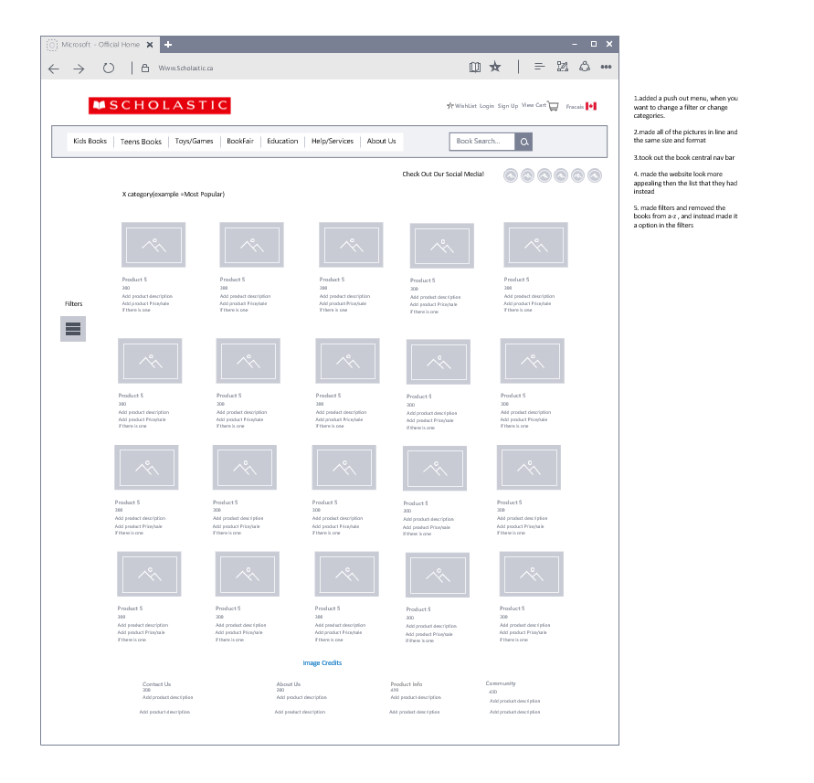

**Differences of websites kids section**

1.added a push out menu, when you want to change a filter or change categories.

2.made all of the pictures in line and the same size and format

3.took out the book central nav bar at the top

4. made the website look more appealing then the list that they had instead

1. made filters and removed the books from a-z , and instead made it a option in the filters, as well as teens books if they prefer those

**FILTERS**

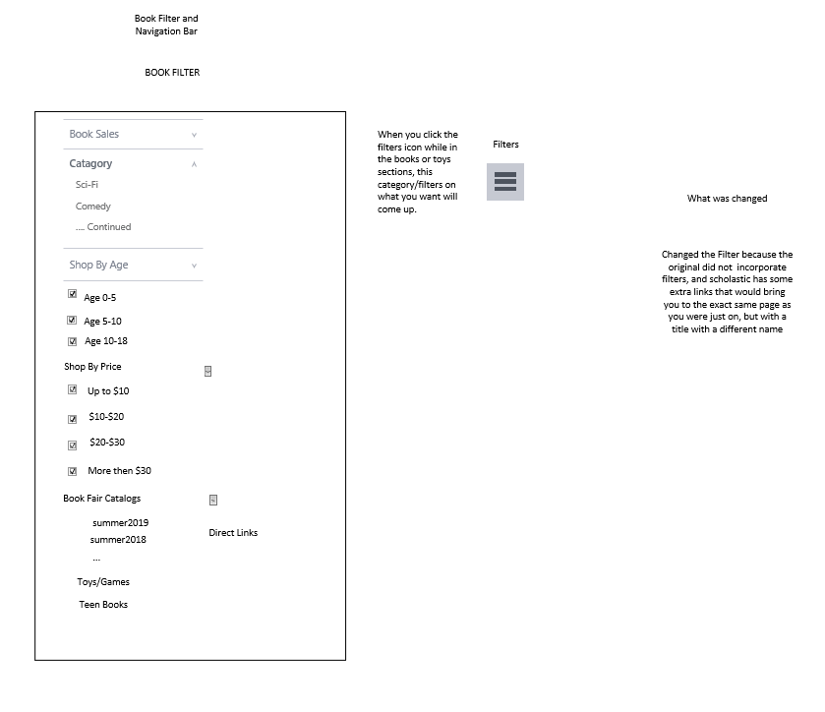

When you click the filters icon while in the books or toys sections, this category/filters on what you want will come up.

What was changed?

I Changed the Filter because the original did not incorporate filters, and scholastic has some extra links that would bring you to the exact same page as you were just on, but with a title with a different name, so I added my own filters

**Navigation bar**

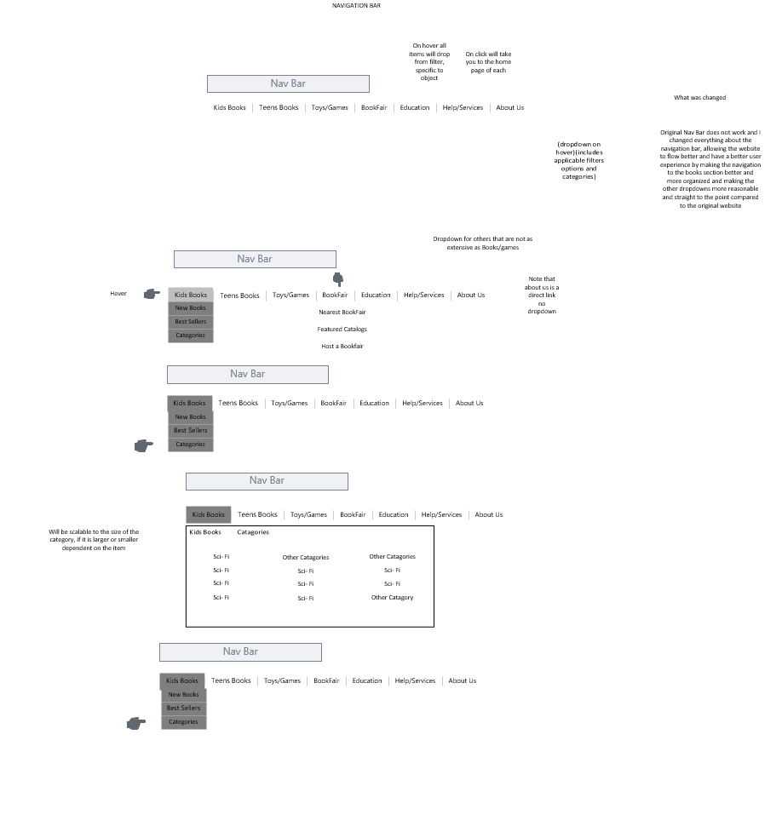

**What Was changed ?**

1. On hover all items will drop from filter, specific to object
2. On click on each of the nav titles, it will take you to the home page of each
3. (dropdown on hover)(includes applicable filters options and categories)
4. Original Nav Bar does not work and I changed everything about the navigation bar, allowing the website to flow better and have a better user experience by making the navigation to the books section better and more organized and making the other dropdowns more reasonable and straight to the point compared to the original website

**Toys and Games (do not have a specific page, just ads for a bunch of different toys)**

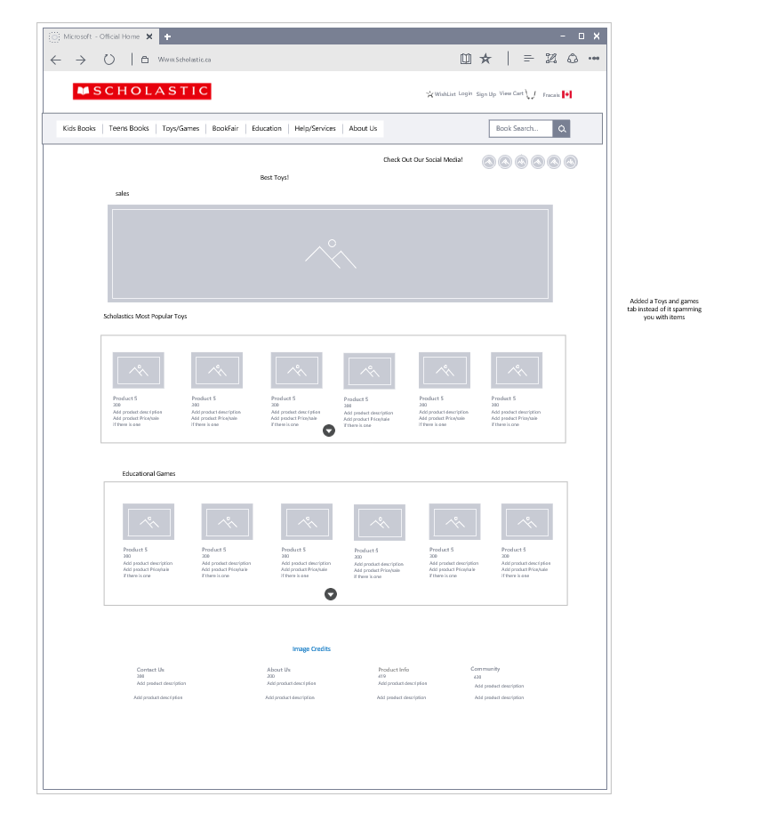

**Bookfair**

Added a Book Fair tab so that people will look for it and be able to find one that is near and set

up one if they wish. The current site, does a horrible job because it is their main way to make money, and they have it hidden in navigation bar categories that don’t make sense

**Scholastic does not have a specific bookfair page, it has a Librarian page that includes it**

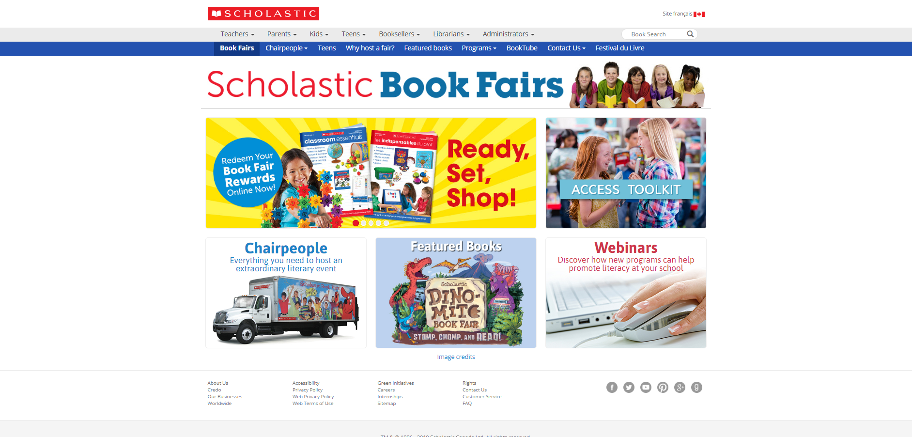

**BookFair Wireframe** 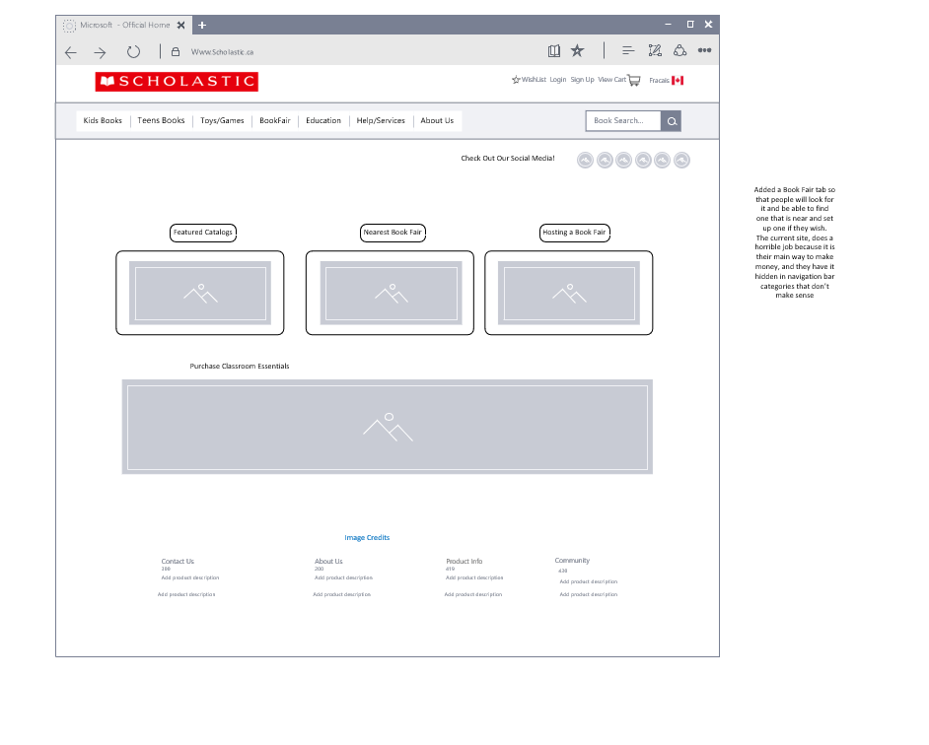

**Scholastic Education Page**

Keeping the similar style of the website, I added this so that the feature because the current website for the Education is very outdated and deserved to be updated because of the unclear and dumb links that lead you nowhere.

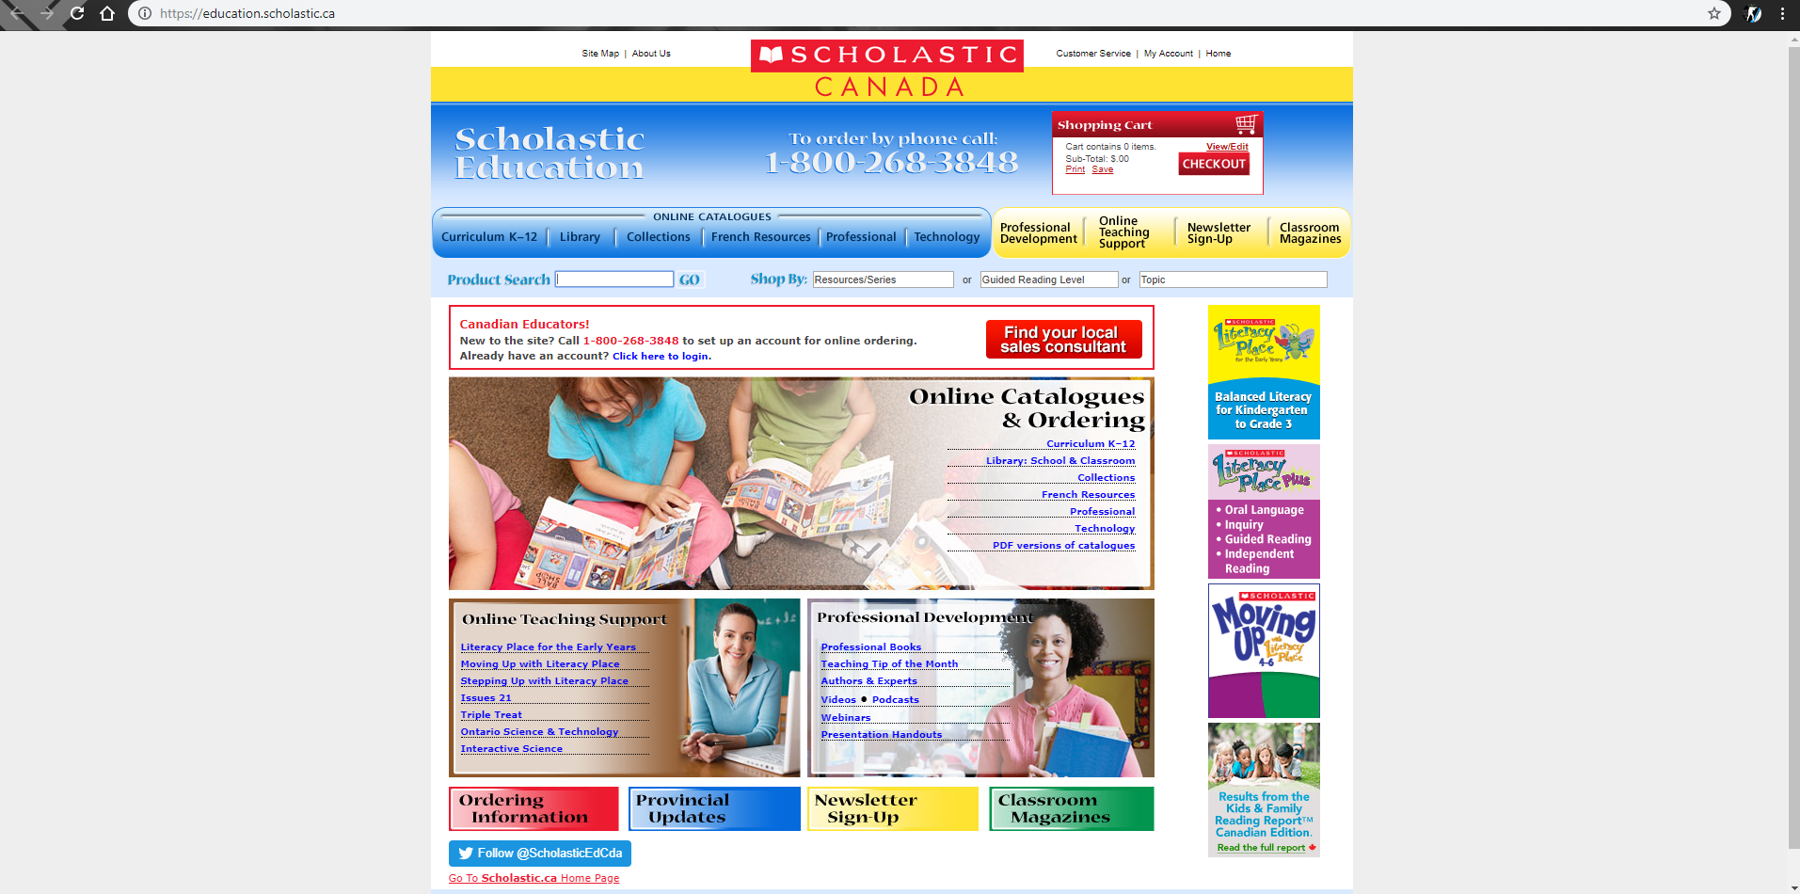

**WireFrame For Education Page**

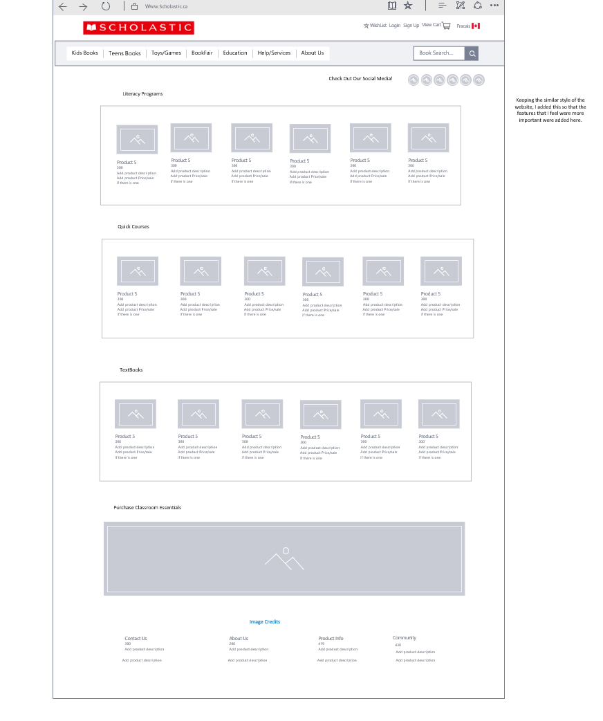

**Help and Services Page**

I changed the help and services page because it did not follow the trend of the original website nor the new one I made, so I changed it so it looks and works better by

1. I changed how the interface looked, because it did not look good and required a lot of reading, which a lot of people would not want to do.(because we skim don’t read)
2. Changed the navigation on the side to be represented by 3 catagories and you can choose which way to navigate the help page
3. Added a way to add questions that they do not ask so you can make a request and feel more involved in the helping of the website
4. Changed it os it followed my design of Scholastic

**Scholastics Help and Services Page**

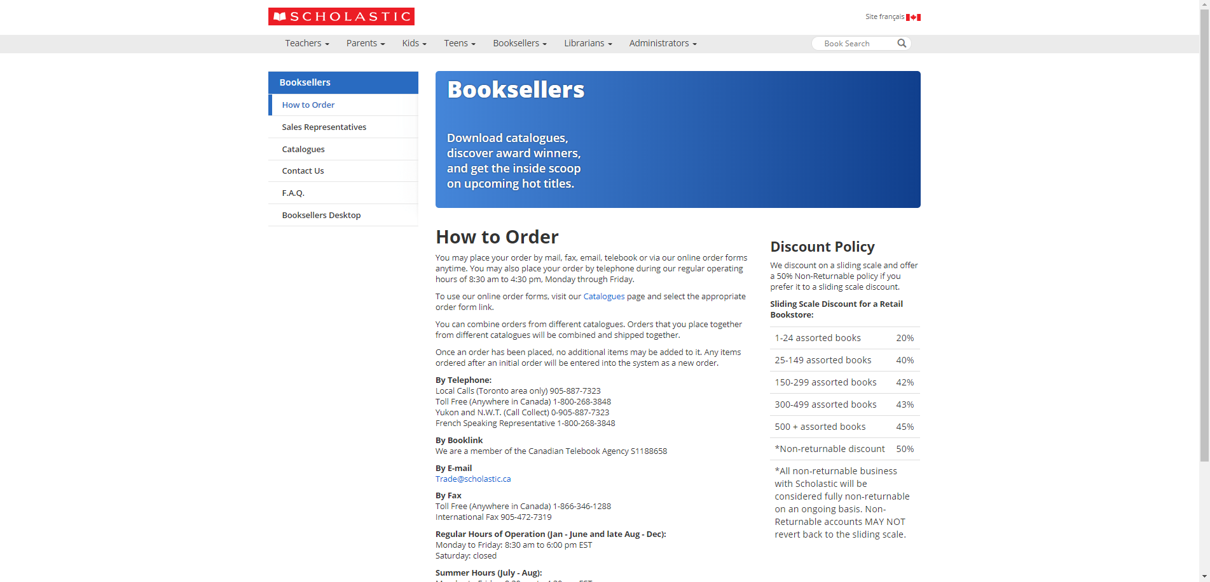

**My Wireframe for Help Services page**

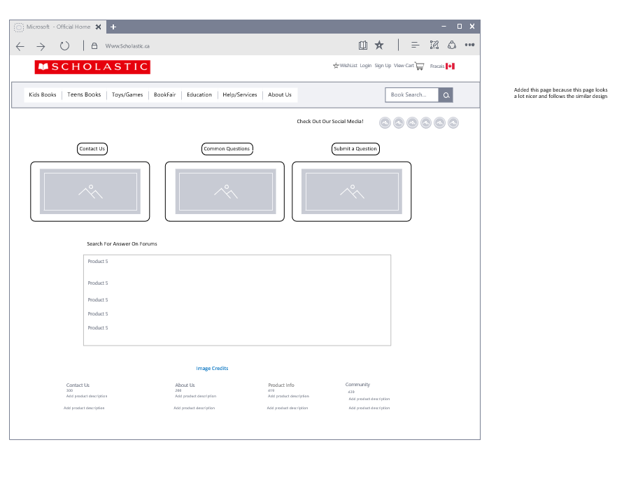

**Scholastic About Me Page**

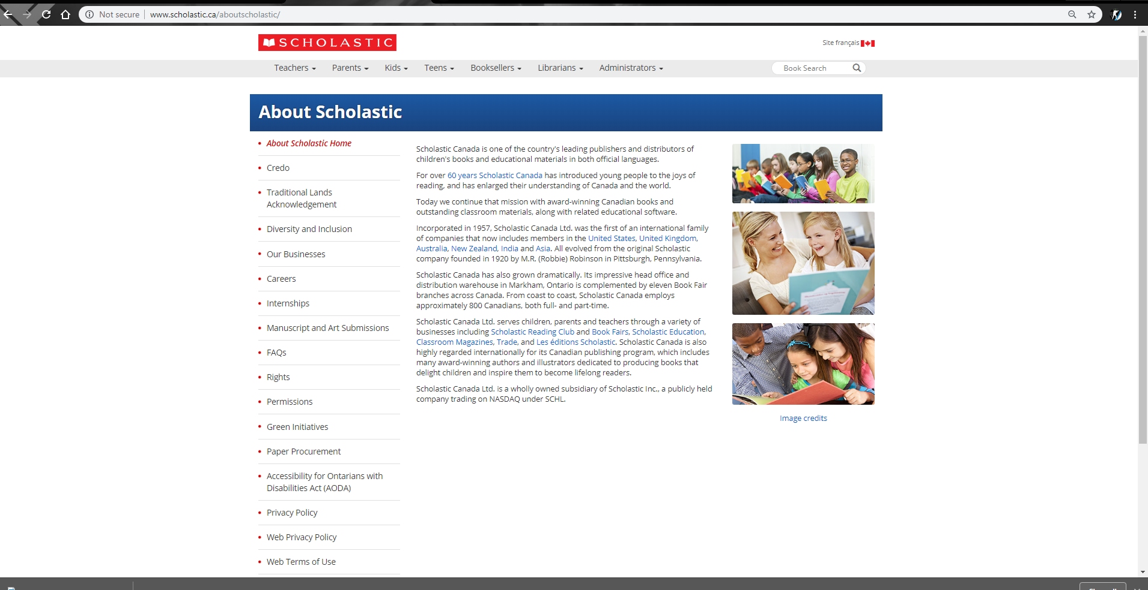

Added this page because I felt that it was not used correctly in the original, it being located at the bottom of the page being hidden and not being able to be accessed normally, so I made it more appealing and changed the design because it looks really bad

1. Changed the random pictures and made it only one
2. Removed the not needed nav bar, and then made the page look a lot more organized
3. added social media icons
4. and made it follow my design flow

**About me page**

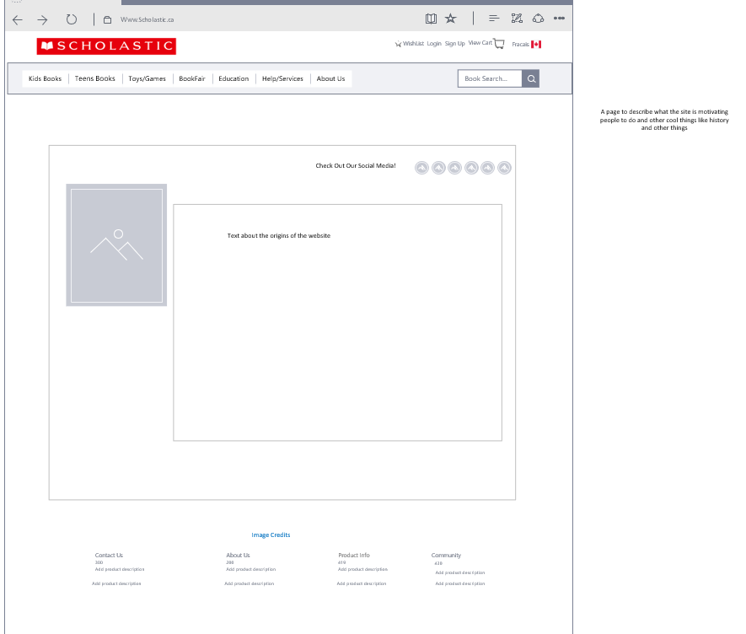

**Wireframe for New Education Page**

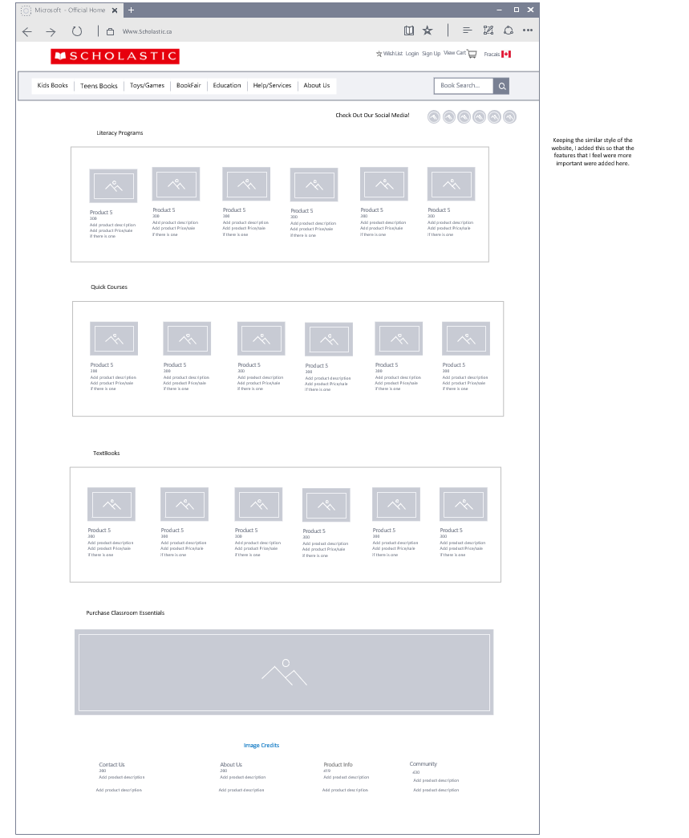

**Payment page for the new website compared to the old**

No specific functional way to buy items on scholastics website at the moment

Way to use new layout

1.The first thing that the user is going to do when clicking on the view cart button, is that they are going to be able to see the books that they added to the cart, and be able to modify quantity, by clicking the quantity, remove an item by clicking remove, and be able to see the total price and price per item

2.See if you want more products, will take you to home page

3. Then when they are satisfied, they will scroll down, see if they have a promotion code , and see if they have any specific instruction upon delivery,

4.When done click “checkout”

5.Then a popup will occur prompting you to continue to payment

6. You will then be prompted to type your billing addresses and items via a popup and greying out of the background,

1. then finally it will take you to a secure page and you will type your payment info in a secure location where it would be harder to get into the websites url

**Wireframe Design for Product Cart and payment**

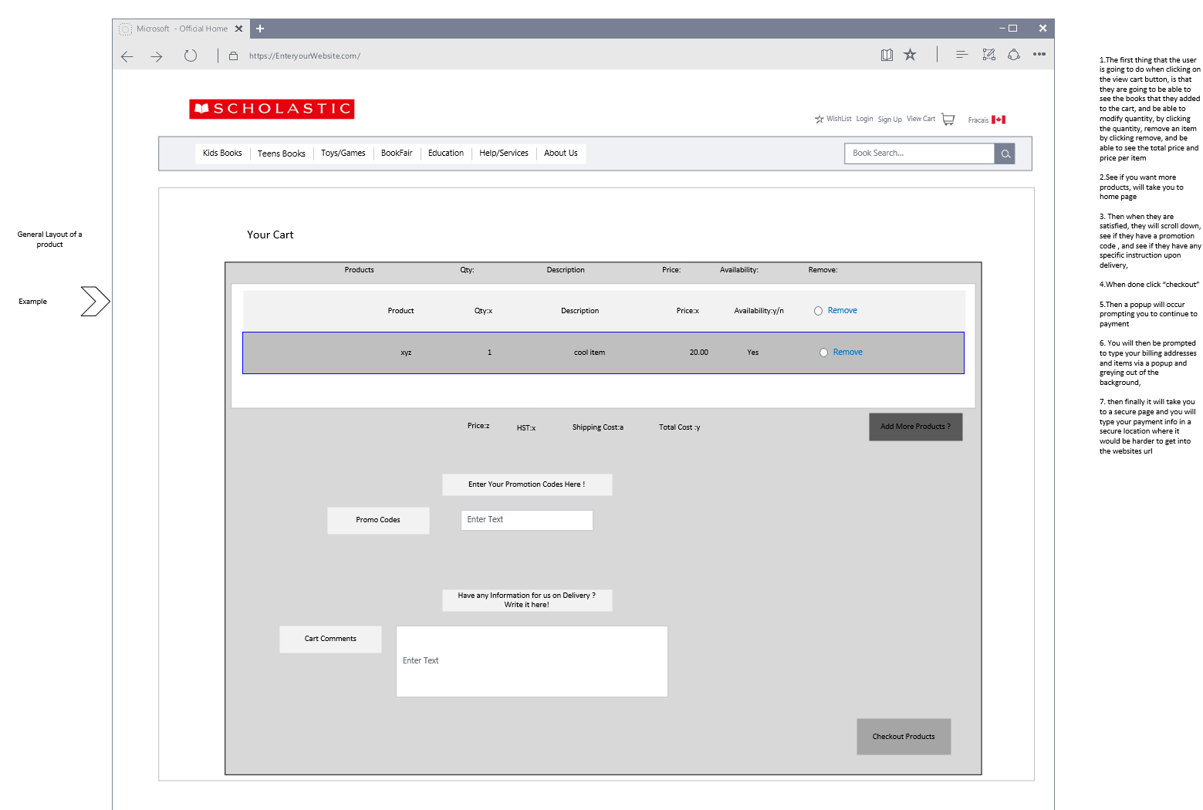

Then you would encounter a pop up when done this page, prompting you to go back and add things or continue to payment

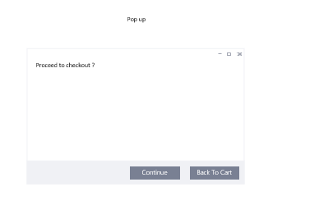

Then there would be another popup, while the rest of the page is grey, where you would type your address, email and that stuff, then you would be directed to the safe page of your car providers website

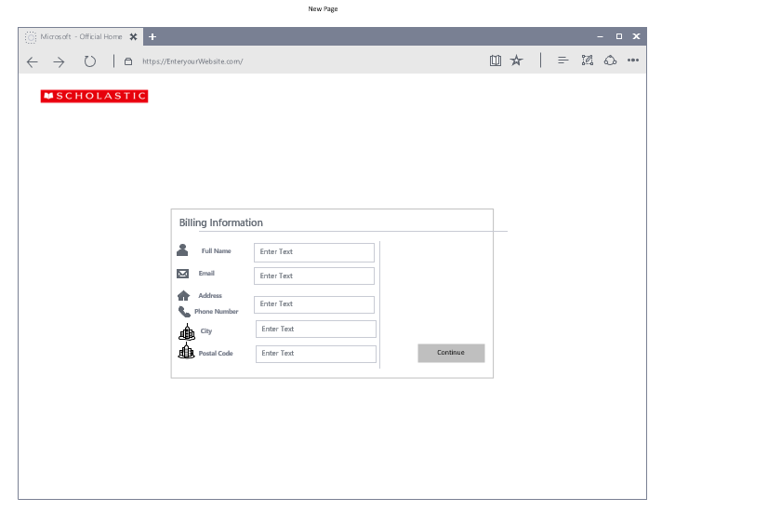

Then it takes you to the card providers website for you to pay

